**Ex. No:3 Roll No: 230701396**

**Date:07/08/2024 Name: M.Praveenraj**

WRITING BASIC SQL SELECT STATEMENTS.

# SELECT employee_id, last_name, sal*12 AS ANNUAL_SALARY FROM employees;

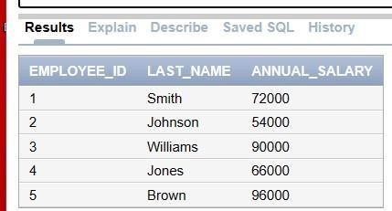

1. Show the structure of departments the table. Select all the data from it.

# DESCRIBE department;

1. Create a query to display the last name, job code, hire date, and employee number for each employee, with employee number appearing first.

# SELECT employee_id, last_name, job_code, hire_date FROM employees;

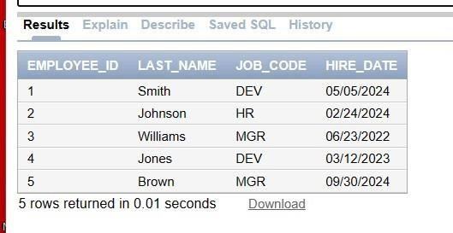

1. Provide an alias STARTDATE for the hire date.

# SELECT employee_id, last_name, job_id, hire_date AS STARTDATE FROM employees;

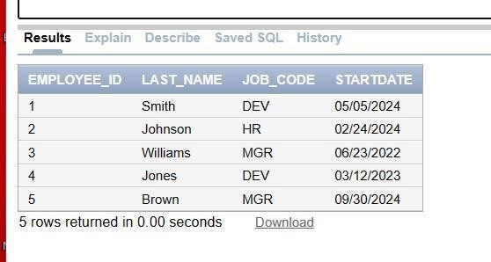

1. Create a query to display unique job codes from the employee table.

# SELECT DISTINCT job_code FROM employees;

1. Display the last name concatenated with the job ID , separated by a comma and space, and name the column EMPLOYEE and TITLE.

# SELECT last_name || ', ' || job_code AS EMPLOYEE_AND_TITLE FROM employees;

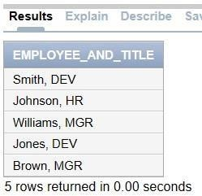

1. Create a query to display all the data from the employees table. Separate each column by a comma. Name the column THE_OUTPUT.**SELECT employee_id || ',' || last_name**

# || ',' || job_code || ',' || TO_CHAR(hire_date,

**'YYYY-MM-DD') AS THE_OUTPUT**

# FROM employees;